**Prototype Lab**

ME 2900

Instructor: Dr. Sandra Metzler

Date of Submission: 10/17/16

Mark Luke

**I. Introduction**

When living in a house with ten roommates, locking the door when leaving and coming into the house can be an issue. To solve this, a prototype sensor was built to detect whether a door is locked or not. The prototype detects the distance the lock is from itself, displays a written message and a green or red light depending on the lock, and also counts amount of times the door is used. Both electrical and physical components had to be used with the prototype, as well as one new actuator and one new sensor. The prototype should be pre-factory quality when constructed. Code for the prototype needs to have at least two user defined functions with variables being passed to and from them. New libraries and several flow structures are also required.

**II. Idea Development Process**

To come up with a solution to ensure my housemates would lock the door, I brainstormed two different prototypes. While similar, they differed in the way they detected the door was opened. The first option used an accelerometer to tell whether the door was open or not, while the second used a distance sensor. Once open, a message and sound would appear for both prototypes, alerting the person to lock the door. Both would use similar programming, the only thing changing would be the logic depending on the sensor chosen. In the end, a hybrid of these two prototypes with added features was chosen.

**III. Discussion**

The final prototype features an accelerometer, IR distance sensor, servo motor, RBG LED, and a 7 segment clock display. The accelerometer waits until it detects an acceleration over 0.15g’s, which simulates a door opening. Then, the distance sensor starts taking readings of the lock. If the lock is locked (turned vertically), the sensor will read a value above 600, and will prompt the RBG LED to turn green and the servo motor to display the LOCKED message. If the sensor reads a value below 600, the LED will turn red, and the servo motor will flip 180 degrees and display an UNLOCKED message. Once this segment of the code is done running, the clock display will display how many times the door has been opened.

In order to read the correct acceleration, the accelerometer had to be calibrated vertically. This forces the Z axis acceleration to be 0g when the prototype is set up on the door. A tiny structure is actually held by springs in place, and when it is deflected, the accelerometer calculates the acceleration from this deflection. The distance sensor shoots out an infrared light, which bounces back into it, and calculates the distance from the intensity of the reflected light.

**IIV. Conclusion**

The prototype created successfully detects when a door is open, and whether it is locked or unlocked. Parts of the servo that work well include the servo motor stating whether the door is unlocked or locked, and the clock display counter. The code for the counter is particularly clever once counting past 9. One difficulty when creating the prototype was when trying to detect the locks position. An optosensor was first going to be used, but it was only reading values when the lock was extremely close to it. This was not ideal, and the switch to the IR distance sensor was made. The distance sensor works much better, and is pretty accurate when sensing the lock. It still does have trouble when detecting a thin object, and can be observed sensing the floor instead of the lock in the video. With more time, a better physical shell would be made around the prototype, as well as attachments to bolt the device onto a door. The distance sensor would be lined up with the lock and screwed in place. A clock would also be added, and the code would be changed to have the sensor only turn on during certain times of the day.

**Appendix A: Photographs of Prototype**

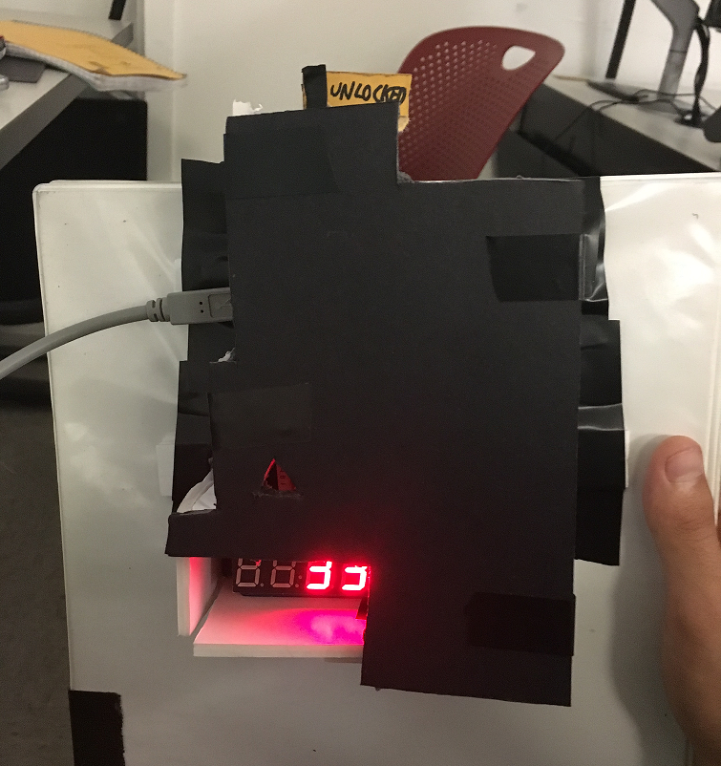Picture 1: Picture of the prototype with the outside shell on.

A1

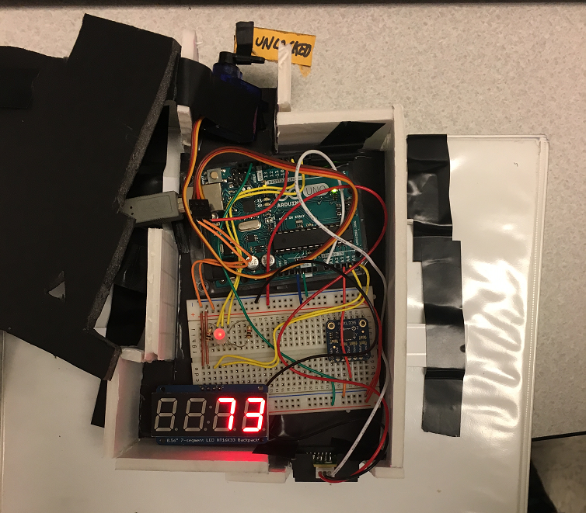

Picture 2: Picture of the prototype showing the electrical components

A2

**Appendix B: Arduino Sketch**

//Backpack display libraries

#include <Adafruit_LEDBackpack.h>

#include <gfxfont.h>

#include <Adafruit_GFX.h>

#include <Wire.h>

Adafruit_7segment matrix = Adafruit_7segment();

//Library for servo

#include <Servo.h>

//Declaring sensors and variables for them

const int distsens = A0;

int distVolt;

Servo myservo; //Declaring the servo as myservo

int pos = 0; //Starting the servo at position 0

//Constants for accelerometer sensor

const int zInput = A3;

//Raw ranges of accelerometer

int zRawMin = 421;

int zRawMax = 629;

//Take multiple readings to reduce the sensor noise

const int sampleSize = 10;

//RGB LED variables

const int ledRED = 8;

const int ledGREEN = 7;

//Counter variable

int i = 0;

void setup()

{

Serial.begin(9600); //Begin communicating with the arduino

analogReference(EXTERNAL); //For the accelerometer

pinMode(distsens, INPUT); //Declare the distance sensor as an input

myservo.attach(9); //Servo attached to pin 9

myservo.write(0); //Sets initial servo position

matrix.begin(0x70); //Begin matrix inputs

matrix.writeDigitNum(4, 0); //Start counter at 0

matrix.writeDisplay();

}

void loop()

{

//Don't need x and y values

int zRaw = ReadAxis(zInput);

// Convert raw values to 'milli-Gs"

long zScaled = map(zRaw, zRawMin, zRawMax, -1000, 1000);

// re-scale to fractional Gs

float zAccel = zScaled / 1000.0;

//Check to make sure still getting right values

Serial.print(zAccel);

Serial.println("G");

if(abs(zAccel) > 0.15)

{

doorOpen();

}

delay(50);

}

B1

// Read the samplesize variable and return the average

int ReadAxis(int axisPin)

{

long reading = 0;

analogRead(axisPin); //Reads pin for accel

delay(1);

for (int i = 0; i < sampleSize; i++) //For loop to take 10 samples

{

reading += analogRead(axisPin);

}

return reading/sampleSize; //Returns average of 10 samples

}

//Code to run when door opens

void doorOpen()

{

delay(4000); //Wait 4 seconds for door to close

int time1 = millis();

int time2, onesDigit, tensDigit;

distVolt = analogRead(distsens); //Reads value of distance sensor, need to figure out values when about 3-4 cm apart

Serial.println(distVolt); //Check to see value

if (distVolt < 600) //Door is unlocked when sensor is less than 600

{

Serial.println("Door is unlocked"); //Checks for testing

delay(500);

digitalWrite(ledRED, HIGH);

do

{

myservo.write(180); //Change the orientation of the servo to display a message

distVolt = analogRead(distsens);

Serial.println(distVolt); //Check to see value

delay(500);

time2 = millis();

if(time2 - time1 > 10000)

{

break; //breaks the loop if the door is not locked within 10 seconds

}

} while (distVolt < 600); //checks until the door is locked

}

distVolt = analogRead(distsens);

Serial.println(distVolt);

delay(500);

if (distVolt > 600) //Door is locked

{

Serial.println("Door is locked"); //Checks for testing

digitalWrite(ledRED, LOW);

digitalWrite(ledGREEN, HIGH);

myservo.write(0); //Moves servo to say door is locked

delay(1000);

}

B2

i++; //Add one to counter

if(i < 100 && i >= 10) //Sets clock display to # of times door opens

{

onesDigit = i % 10;

tensDigit = (i - onesDigit) / 10;

matrix.writeDigitNum(3, tensDigit);

matrix.writeDigitNum(4, onesDigit);

matrix.writeDisplay();

}

else if(i < 10)

{

matrix.writeDigitNum(4, i);

matrix.writeDisplay();

}

digitalWrite(ledRED, LOW);

digitalWrite(ledGREEN, LOW);

}

B3

**Appendix C: Arduino Schematic**

